SPH4U0 **Data Analysis Quest** Name:________________________ Total: ____/28 marks [K/U]

1.Give the number of significant digits in each of the following measurements: [3]

1. 135 000 km= ____________ b) 0.005650 s _______ c) 1.0060 x 10 3 m _________

2. You are testing a radioactive source using a Geiger counter. The source generates 55 counts in given time

interval. How many significant digits are there in this count? Explain your answer. [2]

3. Do the following calculations, rounding off answers to the appropriate number of significant digits. Include correct units in your answer. [3]

a) 27 m x 1.32 m= b) 1.245 s + 0.365 s + 1.7 s = c) (5.60 m/s)÷12.345 s =

4. Perform the following units conversions, expressing your final answer in scientific notation if necessary.

Show your work. [6]

1. 15 000 cm2 = ? m2 b) 1890 cm3= ? m3 c) 85 km/h = ? m/s

5. a) Find the relative (percent) uncertainty in the following distance measurement. [1]

Δ d= 1.65 ± 0.08 m

1. Find the total length and the **absolute uncertainty**. Include the appropriate number of significant digits in your answer. [2]

LTotal = L1 + L2 – L3 L1= 2.4± 0.1 cm L2=58.9 ± 0.4 cm L3 = 6.3 ± 0.1 cm

1. Find the volume and the **absolute uncertainty**: Include the appropriate number of significant digits in your answer. [3]

Volume = length x width x height L= 6.34 ± 0.05 m W=3.97 ± 0.05 m H=4.28 ± 0.05 m

6. The table below shows the result of an experiment to investigate the variation of centripetal force (F) with frequency of rotation(f) when a ball at the end of a string is swung in a circle. Graph the relationship (Force versus Frequency) on the graph paper provided. [3]

|  |  |  |  |  |  |  |  |  |  |  |
| --- | --- | --- | --- | --- | --- | --- | --- | --- | --- | --- |
| Frequency (f)  (Hz) | 0.50 | 1.00 | 1.50 | 2.00 | 2.50 | 3.00 | 3.50 | 4.00 | 4.50 | 5.00 |
| Force (F) (N) | 20.00 | 5.00 | 2.22 | 1.25 | 0.80 | 0.56 | 0.41 | 0.31 | 0.25 | 0.20 |

1. 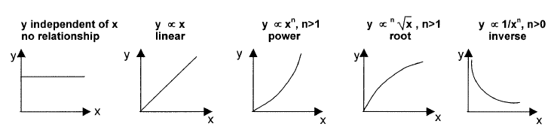Which of the following general relationships best describe this graph? Explain your choice. [2]
2. Demonstrate the graphical analysis process you would use to determine the exact expression for the full mathematical relationship that describes this graph. [3]